Reflective Mailbox/Driveway Marker signs for Sale
** CAN YOU READ YOUR HOUSE NUMBER AT NIGHT? **
The Winfield Community Volunteer Fire Department is selling green and white reflective mailbox/driveway marker signs.
These signs are EXTREMELY effective in helping us to locate you quickly in the event of an emergency!!
Please purchase a sign today. You can mail this form to us with a payment of $12.00, payable to WCVFD to 1320 W Old Liberty Rd Sykesville MD 21784 or you can drop it off to us on your way by. (attn.: Patsy Will)
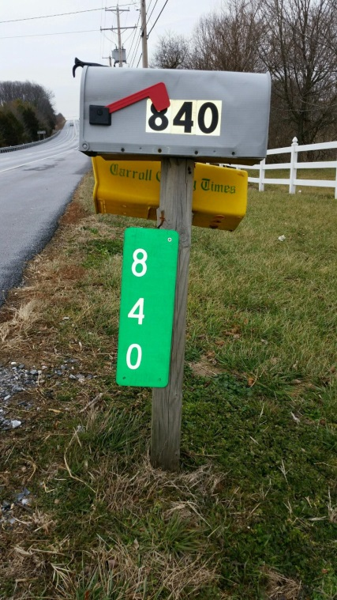
Once complete you will be notified for pickup or delivery. If you need assistance installing it, we can help with that as well.
Name: _______________________________
Address: _______________________________
Phone #: __________________________
Sign Numbers:_________
Vertical or Horizontal (circle one) 5 max. Horizontal 4 max. vertical
Questions: Contact Patsy at 410-795-1333 x336 or fireprevention@winfieldvfd.org

